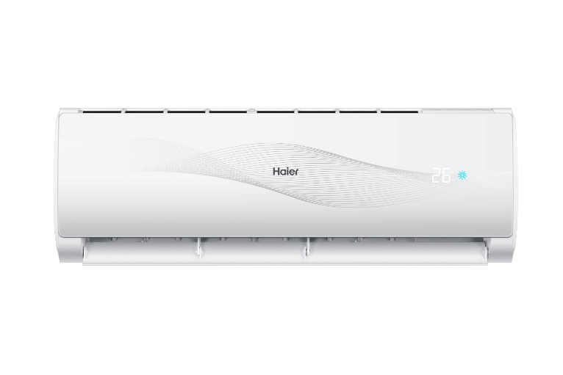

Haier 1 Ton/Triple Inverter Series/12HR (DC Inverter+Self Cleaning+UPS+Heat & Cool)/Air Conditioner/AC/5 Year Warranty/Haier Free Installation

Product details of Haier 1 Ton/Triple Inverter Series/12HR (DC Inverter+Self Cleaning+UPS+Heat & Cool)/Air Conditioner/AC/5 Year Warranty/Haier Free Installation

* Just Call HAIER UAN 042-111-142-437 to avail free installation.
* Brand Warranty
* 05 Years Compressor Warranty
* APAM Technology
* Concealed LED
* Turbo cool
* Anti - Corrosion
* R32 Refrigerant
* Voltage 150-260v
* Running Current (A) 1.4-6.5
* Self Cleaning
* Strong Airflow
* Exquisite Dust Filter
* UPS enabled with device
* Sleep Mode
* Indoor Dimensions W\*D\*H : 833\*288\*205
* Outdoor Dimensions W\*D\*H : 700\*245\*535
* Easy Operation of Controller
* White Body Colour
* Low Noise Operation
* Anti - Corrosion